The Recreation Ground, Bath
Sunday 30th June, 2019

On-the-day event details

About the event
Thank you for signing up for the eighth Bike Bath.
The event is designed by Iconic Cycling Events, the specialist cycling division of Breathing Space. The event will attract over 1,000 cyclists where riders will complete either 25, 50 or 80 mile routes (there is some minor flexibility on the distances).
The event is proud to support Mentoring Plus and we are grateful to all those organisations which have sponsored, supported, and entered as teams or individuals.
We look forward to seeing you on the day!

Location: The Recreation Ground, William Street, Bath, BA2 4DS
https://www.google.co.uk/maps/place/Recreation+Ground/@51.3837651,-2.3562549,17z/data=!3m1!4b1!4m5!3m4!1s0x48718112643f5053:0xc539d6deb720a167!8m2!3d51.3837651!4d-2.3540662

Parking

There is no parking at the venue.
We recommend using the Park and Ride facility on Newbridge Road (3 flat miles from the venue, marked with a blue P on the map below).
There is also a pay and display car park on Charlotte Street (marked with an orange P) that can be used.
The barrier restriction at the Newbridge Park and Ride facility will be manned from 06:30-16:30 on the day of the event meaning that cars with bicycles on the roof will be able to enter the car park without having to remove bikes from their racks.

The route from Newbridge Park and Ride to the Recreation Ground will be signed with black arrows on a yellow background.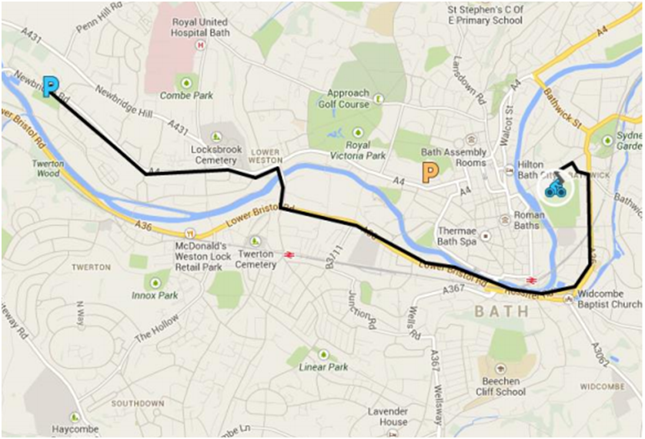
Timings
7.00 am Drinks and breakfast items available to purchase at the Rec.
7.30 am Check in opens
7.45-8.30 am 80 mile route riders register at check-in and will be directed to the start where groups of 15-20 will be briefed and depart. Groups will depart at 3-5 minute intervals.
8.30-9.30am: 50 mile route riders register at check-in and will be directed to the start where groups of 15-20 will be briefed and depart. Groups will depart at 3-5 minute intervals.
9.30-10.30am: 25 mile route riders register at check-in and will be directed to the start where groups of 15-20 will be briefed and depart. Groups will depart at 3-5 minute intervals.
11.30am: Riders will start to return to the Recreation Ground.
12 noon: Relax at the Recreation Ground where drinks and food will be available to purchase.
4.00pm: Close and depart.

R Rider Maps & Emergency Details
All riders will be allocated a rider number which identifies you to the registration details held in event control. This number also has printed on it Event Control and First Aid assistance telephone numbers . We also request that you carry a card detailing any medical issues that the emergency services should be aware of.

Check-In
The rider sign on sheet will be organised in alphabetical order by surname. Please follow the signs directing you to your surname sheet.
Early check-in is available from 17:00 to 18:30 on the evening of Saturday 29th June.

Check-in will open at 07:30 on Sunday 30th June.

If you know someone who will be registering on the day please note that we will be accepting cash only.

You will be asked to show your rider information sheet as proof of entry.
Facilities at Check-In
There will be tea, coffee and breakfast items available to purchase in the start area on Sunday morning on a pay as you go basis. Mechanics will be on hand for any last minute bike adjustments. It is your responsibility to ensure that your bike is roadworthy.

There will also be a bag drop area for those riders wanting to leave a bag during the event. There are toilet facilities at the start area.

GPX and TCX Files

GPX and TCX files for each of the routes are also attached to this email. The support team will be marking the route on Saturday 29th June and adjustments to the route may be required. The Ride Director will advise of any changes to routes at the ride briefing immediately before you set off.

Rider Safety and Etiquette

Please remember that Bike Bath is a sportive and as such is in no way competitive. Riders should ensure they obey the Highway Code at all times and ride in a safe and responsible manner at all times. You must wear a hard shell helmet and will not be permitted to ride without one.

Toilets

There are toilet facilities at all feed stations. Please be sensitive to residents and other road users if you are caught short along the way and either bin or bring back any litter.

Riding with Children

Please ensure that you have returned a parental consent form to us if you are riding with a child.

Route Signage

The route will be marked throughout with white arrows on red backgrounds, before, on and after all significant junctions. Caution signs are placed where cyclists should be extra vigilant.

Particular points on the route e.g. Feed stations and route splits will have signs with black writing on a yellow background. The route from the car park to the start will be marked with black arrows on a yellow background. An example of each of these signs is below.

Signs on route
Signs from Car Park to Start

In the event of you becoming aware that signage has disappeared or been changed, we ask that you inform Event Control at the earliest opportunity.

Feed Stations

There will be one feed station on the 25 mile route, one on the 50 mile route and two on the 80 mile route. These will be well stocked with a range of healthy and high energy food products as well as drinks and a few surprises available. However, we would emphasise that riders should bring sufficient supplies with them for their ride and if you have specific hydration or energy products then please carry these with you.

Rider Support

We will have support vehicles out on the course but riders are expected to be self-sufficient.

We recommend carrying two spare inner tubes, a pump and any necessary tools with you. You should also carry some cash, a form of ID, a mobile phone and your usual brand of energy products.

By signing our terms and conditions and entering the ride, all riders must have:

- Personal identification (with medical information)
- Emergency contact (Name and phone)
- Helmet
- Mobile phone
- Money/bank card
- Water bottle (full) x 2 if hot weather forecast
- Puncture repair kit plus, pump and tyre levers
- Snacks and energy products
- Sun cream
- Waterproof jacket

Timing

Riders will receive a timing chip at check-in with instructions on how to attach it to your bicycle. On returning to the Rec the Bike Bath team will recover the timing chip and sportive number.

Photographs

In line with our efforts to reduce waste, complimentary photographs will take the place of medals this year. Please visit www.sportivephoto.com to download your pictures. The images are 1800 x 1200 pxl and can be produced upto A4.

First aid Cover

There will be first aid trained staff at the Recreation Ground, at all the feed stops and on our support vehicles that will be out along the route who can offer assistance for minor/non-emergency issues (contactable via event control; Event Control tel no - 07528 055110 / Emergency tel no - 07703 391 698). For serious incidents, please note we are unable to transport any casualties and the emergency services will be called.

Riders should always use their common sense and contact the emergency services where necessary. Please do inform the race organisers (using the event control number shown on the rider information sheet) of any major incident.

Emergencies and communications

Details of what to do in case of an emergency will be covered in the brief at the ride start and are summarised on the rider map. Please be aware that areas on the routes may be out of mobile phone signal. Riders are asked to look out for each other and report any accidents or mechanical problems to Event Control, the support vehicles or the event team at the feed stations.

Insurance

Bike Bath carries public liability insurance policy, limited to £5,000,000 for legal liabilities arising from claims made against an event organiser, official or participant that involves either bodily injury or property damage to a third party.

We recommend all riders to have their own personal cover.

Broom Wagon

A dedicated vehicle will follow all riders on the routes and pick up anyone who has had to withdraw from the event for whatever reason. The support team will endeavour to pick up any rider as quickly as possible.

We will start to clear the course from mid-afternoon and would expect to have all riders home by 16:00. If the broom wagon finds you out on the course while clearing you will have the option of taking a lift or carrying on without route markers. If you abandon before the finish or anticipate arriving after 17:00 please ensure you call Event Control to notify them.

Clear Away

Very occasionally for a range of reasons riders are delayed in returning to the event village (starting late, long lunch, getting lost, mechanical problems). Whist we want to ensure all riders have a memorable and enjoyable day we will start to dismantle the event village from 5pm and riders should be aware of this.

Finish Area

As you finish the event we will recover your timing chip. Times will be published on the website within 48 hours of the event finishing. You can then relax at the Recreation Ground with a soft drink or pint of Bath Ales finest!

Post Ride Food

To be able to offer more food choices to both cyclists and spectators, we are not providing post ride rolls this year. Instead, a selection of hot and cold food stalls and the Bath Ales Bar will be open for business at the Recreational Ground on a pay as you go basis.
Charities

We have riders taking part in the event raising money for a large number of charities this year including our supported charity Mentoring Plus.

We look forward to seeing you in Bath
and hope that you have a great day
We would like to give a big thanks to all our sponsors and friends of Bike Bath:

Redrow Homes, Hawke Ridge, Spilsbury Illustration, OTE, Bouda Vida, Sunwise, Moulton bikes, Cyclescheme, Road.cc, Carter Jonas, John’s Bikes; Marshfield Bakery, Fyffes bananas, Bath Ales; Carter Jonas, the Bath Soft Cheese Company; Julian House Workshop, Scheckter’s Organic Energy, Barbers Wensleydale and Oxford Blue cheese, Jordans Fruseli and the Rec Trust.

